FAQ Chatbot Project

Chatbot V2

**By D R Shepherd**

Contents

**Overview** 3

Market research 3

Test plan 3

Bot code 3

Client to Server and Server to Client 4

Admin side 4

Development 4

Testing 5

Bot code 5

Client to Server and Server to Client 7

Admin side 8

Evaluation of tests 9

Deployment of the system 10

Evaluation 10

# **Overview**

Version 1 of the chatbot worked very well, however there were occasional misunderstandings as well as more technical problems like memory. I wanted to rewrite the code to be more efficient and have a better grasp of language analyses and memory organization. I would introduce dictionaries to make look up of data more efficient. I also want to introduce storing memory with the date and having some items only valid within a certain date.

I will also be removing the question and statement split method from the code as it was unneeded functionality.

# Market research

The market research remains the same from the previous paper. No new research was conducted for this version. The ideas of new features came from testing the system and wanting to clear up bad functionality.

# Test plan

The following tests are designed to know when the system works at the different areas of development, I will use the same test plan as the previous version, as the functionality remains the same. There will however be a few new additions. I removed the question and statement split as it was unneeded.

## Bot code

|  |  |  |
| --- | --- | --- |
| Test No | Test | Expected outcome |
| 1 | A question which has been added will find a response. | The result set to that question is outputted |
| 2 | A question is not found but there are saved questions about that topic. | The system will add the question to a confused file, to be added by the admin at another point. Then will find something like that and state “I am not sure at the moment but here is something similar”. |
| 3 | A question which has never been asked and is not entered | The system will add it to the confused file and apologise for it does not have an answer at this point. |
| 4 | Data already in the confused file is added | The data will not add it again but will increase its priority |
| 5 | A paragraph is entered with a vague sentence following another sentence. “what mental health services are there? Where are they” | The paragraph is split, and the previous topic remains the current topic to help find out what the second sentence means. “where are they” + “mental health services” |
| 6 | Information that is past the time limit will not be returned | The user enters in a question which was saved with an expired limit. It should return that it cannot find information. |

## Client to Server and Server to Client

|  |  |  |
| --- | --- | --- |
| Test No | Test | Outcome |
| 1 | The client connects to the server | A test code is sent and pinged back |
| 2 | The client sends the text input out to the server | A response is sent back based on the input |
| 3 | The client responds negative feedback to a message | The system receives information about what is wrong, and it adds it to be added in the confused file. |

## Admin side

|  |  |  |
| --- | --- | --- |
| Test No | Test | Expected outcome |
| 1 | Makes user sign in with correct credentials. | If the password and username is wrong, then it returns wrong. If not, then it lets the user in. |
| 2 | The user can receive the top amount of questions to add. | The user sends a request via the GUI and gets a response |
| 3 | The user can answer questions. | The question and answer are submitted and trained into the system. |
| 4 | The user disconnects | Their IP is no longer saved in the server-side code and they will have to re-enter their password and username. |
| 5 | The user can delete responses which are incorrect | The user selects delete and it no longer appears in the data. |
| 6 | The information being saved can be given a time limit. | The user is given the option to select a time until this information is valid |

# Development

Many of the features I am using I took from the previous version or SHEP V 0.0.10. The language processor code was introduced from the latest SHEP version. It provides features from the NLTK library and wordnet to find frequent topics within text, which helps the new chatbot system organize its data. The language processor also finds how similar sentences are based on structure and topics. These features will improve accuracy from the last system.

I wrote the new version to use completely json files rather than have a mixture of json and databases. The database was an annoying feature which didn’t really fit with the code. This new version breaks up into log files, held as an object, and a confused file. All of which are json files due to the logical structure they provide.

I used the same botclient and adminClient classes from the previous version, with slight changes to fit with the new system. This means I did not have to change much with the JavaScript as all the features I added in the last code worked.

After embedding it on a new website, I made some changes to its features such as the ability to select a date. This required some changes such as a new input box to add information. I will have to consider when implementing date checks in the back end that when the user end adds through positive feedback, we should

# Testing

## Bot code

|  |  |  |
| --- | --- | --- |
| Test No | Test | Expected outcome |
| 1 | A question which has been added will find a response. | **PASS** |
| 2 | A question is not found but there are saved questions about that topic. | The system finds the answers which are similar.  Another one where I saved the answer to “when does the coop open” and asked the following:    It found relevant information  **PASS** |
| 3 | A question which has never been asked and is not entered | The system tells me it does not understand and adds this sentence to the confused file.  **PASS** |
| 4 | Data already in the confused file is added | These two items are waiting to be added.  As I ask more of one it gets higher in priority      It goes to the top of the list  **PASS** |
| 5 | A paragraph is entered with a vague sentence following another sentence. “what mental health services are there? Where are they” | The paragraph is split, and the previous topic remains the current topic to help find out what the second sentence means. “where are they” + “mental health services” |
| 6 | Information that is past the time limit will not be returned | The user enters in a question which was saved with an expired limit. It should return that it cannot find information. |

## Client to Server and Server to Client

|  |  |  |
| --- | --- | --- |
| Test No | Test | Expected outcome |
| 1 | The client connects to the server | The message hi is sent and the saved response to it is pinged back.  **PASS** |
| 2 | The client sends the text input out to the server | I send a message and the message is returned.  **PASS** |
| 3 | The client responds negative feedback to a message | The wrong information is given, so the user responds using the negative feedback option.  **PASS** |

## Admin side

|  |  |  |
| --- | --- | --- |
| Test No | Test | Outcome |
| 1 | Makes user sign in with correct credentials. | **PASS** |
| 2 | The user can receive the top amount of questions to add. | The user sends a request via the GUI and gets a response  This was shown in test 4 of the main bot testing  **PASS** |
| 3 | The user can answer questions. | The user is able to enter information and it will come up in the answers.    **PASS** |
| 4 | The user disconnects | Their IP is no longer saved in the server-side code and they will have to re-enter their password and username.    **PASS** |
| 5 | The user can delete responses which are incorrect | **PASS** |
| 6 | The information being saved can be given a time limit. | The user is given the option to select a time until this information is valid.    I replaced the previous add with a pop up that has date selection    The date appears in the log file if there is an item. If not then it has nothing.  **PASS** |

# Evaluation of tests

I found that I needed to adapt the subject weight importance when the code finds the similarity between sentences. I did this in the language processor code.

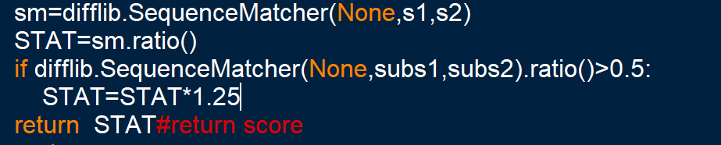

This would increase it by 25%

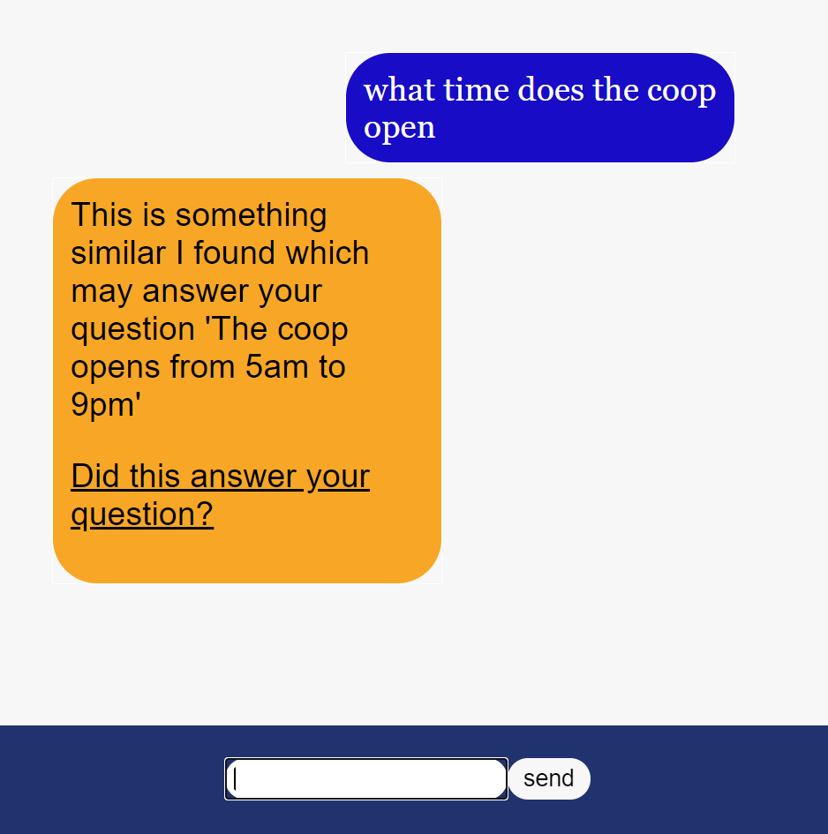

# Deployment of the system

# Evaluation